**Fixed Price Billing SOP & Exceptions**

Table of Contents

I. Create FP Billing Event 1

II. Generate Draft FP Customer Invoice 3

III. Release Approved Invoice (Post Project Manager’s Approval) 7

IV. Closing Ticket in Service Now 9

V. Exceptions 10

A. Itali (530) 10

B. Philippines (430) and Singapore (435) 12

C. Malaysia (436) and Thailand (437) 13

D. Poland (740) 14

E. Mumbai (440) & Pune (845) 17

Table of Versions

|  |  |  |
| --- | --- | --- |
| Sr. No. | Date | Version |
| 1 | 23/01/2025 | SAS-FP-SOP-V1 |
| 2 | 10/02/2025 | SAS-FP-SOP-V2 |
| 3 | 24/03/2025 | SAS-FP-SOP-V3 |
| 4 | 04/04/2025 | SAS-FP-SOP-V4 |

# Create FP Billing Event

1. Click on Navigator > Contract Management > Invoices.

1. Click on Tasks Panel and select Manage Events.

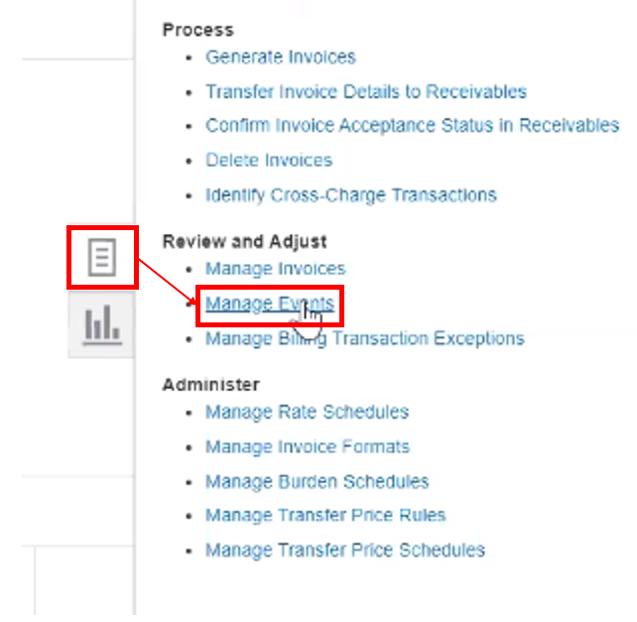

1. Check if any existing event is created in invoicing to avoid duplication.

Business Unit  
Contract Number

Search

Note: to identify if event exists for same invoice check the contract number, contract amount & date of event.

1. If no existing event > Click on '+' icon under Search Results section to create an Event.

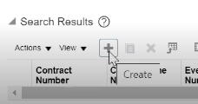

1. Enter required fields:  
    Business Unit, Contract Number & Contract Line   
    Event Type = Milestone Invoice  
   Event Description **=** Description of the milestone achieved Amount in Bill Transaction Currency = Invoice Milestone Amount  
    Completion Date  
    Project Name  
    Transaction Task Name (top task associated with contract line)
2. Review Event Revenue and Invoice eligibility, confirm correct.
3. Select 'Work Type - Tax Code' under 'Additional Information' section.
4. Click on 'Save and Close'.

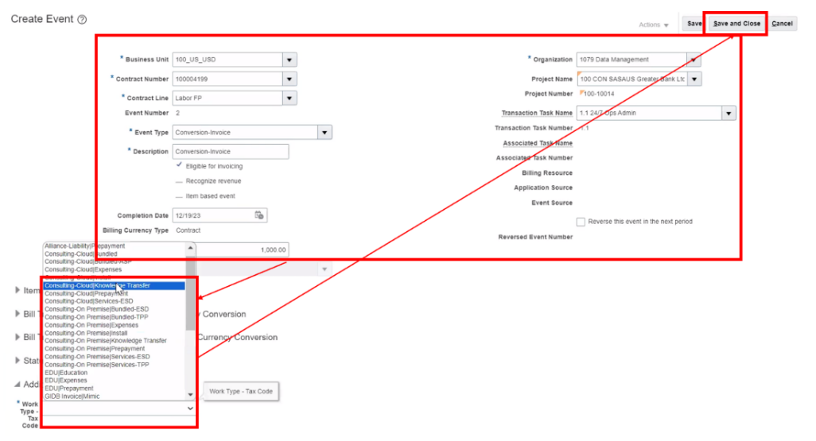

# Generate Draft FP Customer Invoice

1. Click on Navigator > Contract Management > Invoices.

1. Click on Tasks on the right-hand side.
2. Click on Generate Invoices.

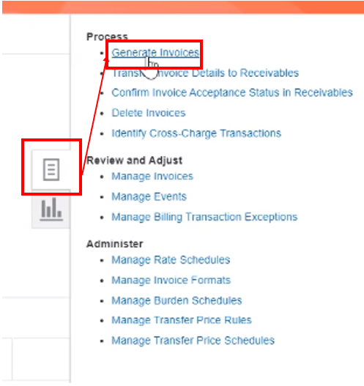

1. Input Parameters and click Submit:

Business Unit = XXX_CC_CUR   
Billing Type = External  
Bill Through Date = adjust as needed; will capture only expenditures through this date.  
Invoice Date = adjust as needed; date will print on invoice.  
Contract Number = 9-digit contract number  
Generate Ineligible Data = Detail  
Debug Mode = Yes

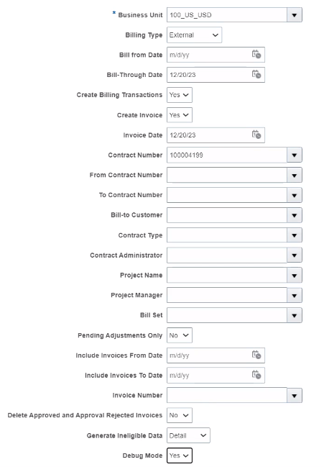

1. Expand Process Monitor dropdown & click the Refresh icon.
2. Click Refresh until the status of the report equals 'Succeeded'.

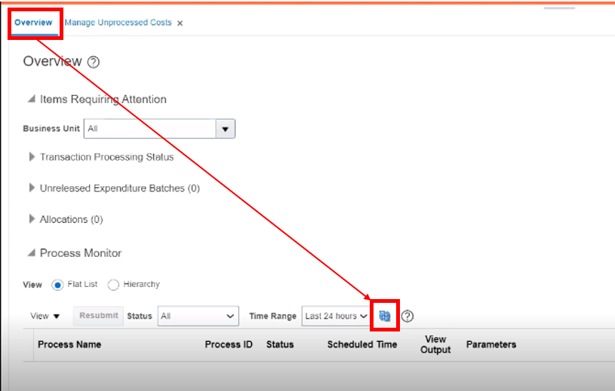

1. Review invoice processing status:
2. Click on the View Output icon next to the Generate Report option of the process.
3. Click the Republish icon.
4. Click the yellow View Report icon.
5. Select PDF.

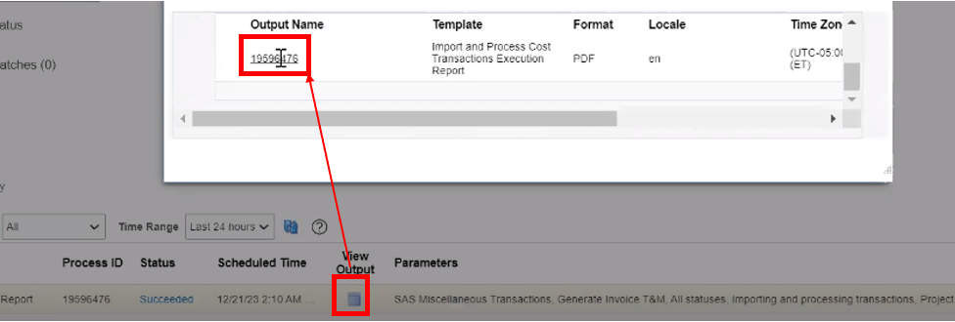

1. Navigate to Contract Management > Invoices.

1. Select 'Manage Invoices' from Task Panel.

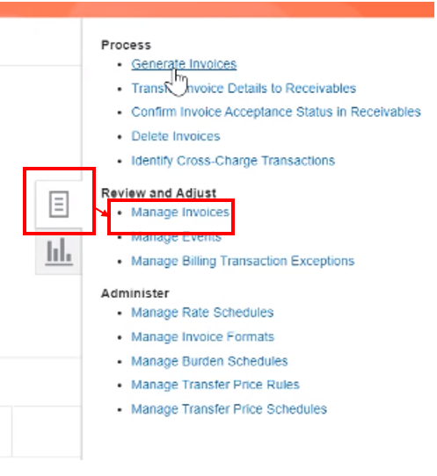

1. Select Business Unit from the drop-down list and key in 'Contract Number', then click on search button > Business Unit, Billing Type = External, Contract Number = 9-digit contract number
2. Click Invoice Number to open draft invoice.
3. Validate Invoice Description, Event Descriptions and Work Types.
4. Click the Submit button.

# Release Approved Invoice (Post Project Manager’s Approval)

1. Contract Management > Invoices.

1. Click on Task Panel > Review and Adjust > Manage Invoices.



1. Enter Business Unit, Contract Number and status as 'Approved'.
2. Click on Search.

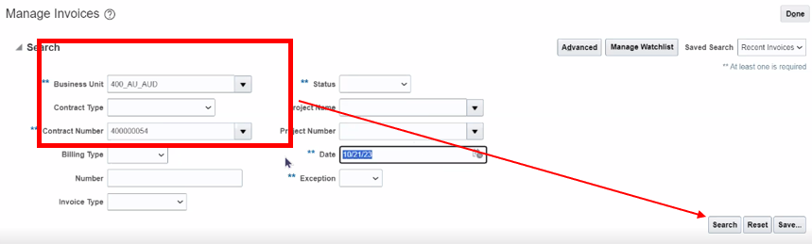

1. Highlight the appropriate Invoice.

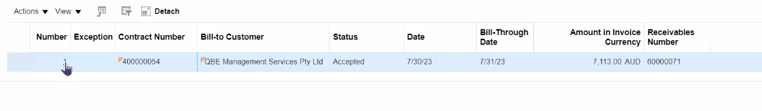

1. Go to Actions > Release.

1. Once the Invoice in Released Tab the status will be “Released”. After the status changes from “Released” to “Accepted”, an 8-digit Invoice/Receivable Number will be shown:

# Closing Ticket in Service Now

1. Visit service now ticket portal and click on the ticket number

1. Mark the ticket as “Fulfilled”

1. Paste the 8-digit invoice number in the “Invoice #:” field

1. Click on “Update and Return”

# Exceptions

## Itali (530)

1. How to identify the Tax type for Italy Customers

While creating the budget for the project, there is an exception we follow for Italy region regarding Tax Type.

First, we go under **Manage Financial Project Settings**, you will see the screen as below for project under Fusion.

Here, there are two fields that we need to enter. One is Context Prompt, and another is Tax Type.

We must select the Context Prompt as **INVOICE ITALY** and there are three types of taxes which are as follows:

* I - For given type we use tax code “**I**”
* SP - For given type we use tax code “**S**”
* I*SP - For given type we use tax code “**S**”

1. Examples as Follows for all Tax types of Customers and you will find the

For customer “Accenture Financial Advanced Solutions and Technology & SRL” the tax type is I, So will be considering “I” as Tax type.



For customer “Alma Mater Studiorum – Universita Di Bologna” the tax type is SP, So will be considering “S” as Tax type.



For customer “Age. Na. S – Agenzia Nazionale per I Servizi” the tax type is I*SP, So will be considering “S” as Tax type.



## Philippines (430) and Singapore (435)

1. In Philippines and Singapore, we add Billing instructions as “**Do not send to Client, PM to Check**” and attachments as well.

1. In Singapore we upload invoices on customer portal. There are two customers i.e., OCBC & Ariba. The invoices generated in Fusion will be copied to the Project Manager and DMO.

1. In Philippines, due to government regulations, the invoice needs to be manually created by the SAS local finance team and send it to the customers. Invoices from Fusion will be generated as per process and mark the local finance team in copy. When the manual invoices are created by the team, they will copy DMO and TCS team while sending to the customer.
2. Local finance contact:
3. Maria Rosalie Alicante - Rosalie.alicante@sas.com
4. Sharon Flores - Sharon.Flores@sas.com

## Malaysia (436) and Thailand (437)

1. In Malaysia and Thailand, we do not add billing instructions, but we add attachments.

## Poland (740)

1. ING invoices - Customer Name: ING Bank Śląski S.A.

There is a specific requirement by this customer that they want a different name on the “Bill to Site” and a different name on the “Ship to Site”.

There is something called the NIP number or the tax number, which we cannot see on the preview invoices, but it's something that will be visible on the final invoice after the PDF is generated **because there are two different entities i.e., one is parent company (ING Bank Śląski S.A.), and another one is subsidiary company (Grupa VAT ING, Grupa VAT Pekao).** In such case the address will be the same, but the name of the customer will be different, hence there is requirement that a different name should be on the bill to site and on the ship to site and therefore two different NIP numbers should appear on.

The final invoice, to achieve this, we need to create the contract in a different way. so first we need to amend the contract because it was created incorrectly.

For the contract amendment we can use the below mentioned contract number as ref.: 740000045

1. Steps to Amend the Contract.
2. Go to the Action Tab then select the option Amend

1. For example, contract number 740000439 will go and amend
2. Go to Parties tab change the Customer Name from ING Bank to Grupa VAT ING

1. Once we change the Customer in Parties tab The same customer Information need to be update in Bill to site as well.
2. Note: Only Bill-to site need to change Ship-to site remains the same.

1. Go to Lines tab > Check the Ship to site should be aligned with the same information which we put in Parties tab.

1. Go to Billing tab > Bill Plans > Click on Labor FP Bill Plan
2. Customer information should be the same as we have filled in Parties Tab.

1. Note: For all ING projects, whether it's time and material or fixed price, we need to record the PO Number (Purchase Order Number) in contract.
2. Billing Tab

1. Lines Tab< Billing < PO Number

1. Once we update amended the contract, we need to put amendment effective date (Project Start date) and submit the contract for Approval.
2. **Split Invoice** -In the Polish region, the projects are splits into percentages and several contracts associated to split projects. For instance, 65% of the contract value should be invoiced to party “A” and the remaining 35% to party “B”.
3. **For Example:** The projects will have to be created separately by PM. If the contract value is 100,000 PLN, and the split is 65 to 35 percent, both projects will be used to invoice the 65% and remaining 35% because there are two customers (the split can be varied for instance, 50-50% or 95-05%)The DPM attached will be full value of the contract also split information must be mentioned in the project under notes.

1. Both Revenue and raw cost will be split between projects as 65% and 35%. The invoice will be events based (Milestone) and Revenue method (Amount Based) only because it is not possible for the project managers to modify the hours according to the splits. So, the contract record must be created using a time and material template, though Project Task Rate Overrides and Cost Rates Overrides will be skipped.

## Mumbai (440) & Pune (845)

1. For customers ICICI, TATA, SBI we need to send Email to ourselves “Do not directly send emails for these clients”.
2. List of customers where digitally signed invoices and customer portal upload is required:

|  |  |  |  |
| --- | --- | --- | --- |
| **Customer Name** | **Invoice Sent to Customers** | **Customer Requirement** | **Invoice Submission Process** |
| SBI Cards | Copied to PM and DMO email IDs | Digitally Signed | Digitally Signed invoice copy is being uploaded to client's portal |
| Client's portal Invoice Upload |
| Accenture | Copied to PM and DMO email IDs | Digitally Signed | Digitally Signed invoice copy is being uploaded to client's portal |
| Client's portal Invoice Upload |
| TATA AIA | Copied to PM and DMO email IDs | Digitally Signed | PM to send digitally signed invoice to client from his/her email ID |
| HDFC Bank | Copied to PM and DMO email IDs | Digitally Signed | Digitally Signed invoice copy is being uploaded to client's portal |
| Client's portal Invoice Upload |
| Airtel | Copied to PM and DMO email IDs | Client's portal Invoice Upload | Final Invoice copies are being uploaded to client's portal but digital signature not mandatory |

1. GST will not be calculated if the currency is other than INR.

***Process End***

Escalation Matrix

|  |  |  |  |
| --- | --- | --- | --- |
| Name | Level | Email Address | Landline/Phone Number |
| Bhaswar Banerjee | Level 1 | bhaswar.banerjee@sas.com | N/A |
| Agnieszka Bartuzi | Level 2 | agnieszka.bartuzi@sas.com | +48 22 560 45 83 |
| Beata Kienorow-Gulan | Level 2 | beata.kienorow-gulan@sas.com | +48 22 560 45 69 |